**VISVESVARAYA TECHNOLOGICAL UNIVERSITY**

**Jnana Sangama, Belagavi – 590 014**

 **A Database Management System Mini Project Report On**

**“ONLINE JOB PORTAL SYSTEM”**

**Submitted in Partial fulfillment of the Requirements for the V Semester of the Degree of**

**Bachelor of Engineering**

**In**

**Computer Science & Engineering**

**ByRAKSHA B KOTTARI (4MW19CS073) RAKSHITH ACHARYA (4MW19CS121)**

**Under the guidance ofDr. NAGARAJ BHATAssociate Professor and Head**



**Department of Computer Science and Engineering**  **SHRI MADHWA VADIRAJA INSTITUTE OF TECHNOLOGY AND MANAGEMENT**

**Vishwothama Nagar, BANTAKAL – 574 115, Udupi DistrictJANUARY, 2022**

**Shri Madhwa Vadiraja Institute of Technology and Management**

(A Unit of Shri Sode Vadiraja Mutt Education Trust ®, Udupi)

**Vishwothama Nagar, BANTAKAL – 574 115, Udupi District, Karnataka, INDIA**

**Department of Computer Science and Engineering**

***Certificate***

Certified that the Database Management System Project Work titled **‘ONLINE JOB PORTAL SYSTEM’** has been carried out by **Mr.** **RAKSHITH ACHARYA** (**4MW19CS121) and Ms. RAKSHA B KOTTARI (4MW19CS073),** who are the bonafide students ofShri Madhwa Vadiraja Institute of Technology and Management, in partial fulfillment for the award of **Bachelor of Engineering** in Computer Science and Engineering ofVisvesvaraya Technological University, Belagaviduring the year 2021-22.The Database Management System Mini Project Report has been approved as it satisfies the academic requirements with respect to the project work guidelines prescribed for the said Degree.

**Dr. NAGARAJ BHAT**

Project Guide & HOD

Dept. of CSE

**Name of the Examiners: External Viva Signature with Date**

1.

2.

**Acknowledgements**

**________________________________________________**

We express our deepest gratitude and respect to our guide **Mr. NAGARAJ BHAT**, Senior Lecturer, Department of Computer Science and Engineering, for his valuable guidance and encouragement while doing this project work.

We are indebted to Prof. Dr. Thirumaleshwara Bhat, Principal, for their advice and suggestions at various stages of the work. We also extend our heartfelt gratitude to Mr. PQR for his assistance.

We extend our thanks to the Management of Shri Madhwa Vadiraja Institute of Technology and Management, Bantakal, Udupi for providing good laboratory and library facilities. We also remain grateful to the co-operation and help rendered by the teaching and non-teaching staff of the Computer Science and Engineering Department.

Lastly, we take this opportunity to offer our regards to all of those who have supported us directly or indirectly in the successful completion of this project work.

Raksha B Kottari (4MW19CS073)

Rakshith Acharya (4MW19CS121)

**ABSTRACT**

The purpose of online job portal is to automate the existing manual system by the help of computerized equipment and full-fledged computer software, fulfilling their requirements, so that their valuable data, information can be stored for a large period with easy access and manipulation of the same. The required software and hardware are easily available and easy to work with Online job portal, as described above can lead to error free, secure, reliable and fast management system. The Online Job Portal System, manage the details of Employer, Employer Registration, Posts about Jobs, Search Job. It manages all the information about Employer, Job Seeker, Search Job, Posts about jobs etc. The project is totally built at administrative end and thus only the administrator is guaranteed the access. The purpose of the project is to build an application program to reduce the manual work for managing the Employer, Employer Registration, Post Job. It tracks all the details about the Post Job, Search Job so on… The application storage of the data has been planned. Using the constructs of MYSQL Server and all the user interfaces have been designed using the PHP, HTML, CSS, BOOTSTRAP, JAVASCRIPT technologies. The database connectivity is planned using the “SQL Connection” methodology. The standards of security and data protective mechanism have been given a big choice for proper usage. The application takes care of different modules and their associated reports, which are produced as per the applicable strategies and standards that are put forwarded by the administrative staff. A job portal helps both the job seekers and recruiters finding the right organization for the employees. In the case of job seekers, according to their educational qualification, experience and their preferences, the job portal shows the list of companies to the job seeker. And, to the recruiters, provides the suitable candidates from a pool of lacks. The objective of this application is to develop a system to enable interaction between employers and applicants. The determination is to allow communication between the interested parties and complete the task of recruitment quickly.

**Table of Contents**

**Page No.**

**Acknowledgements** i

**Abstract** ii

**Table of Contents** iii

**Chapter 1 Introduction**

1.1 Introduction of the project 7

1.2 The present study 7

1.3 Motivation to do the project work 7

**Chapter 2 Literature Review** 8

**Chapter 3 Data and Tool**

3.1 Hardware 10

3.2 Software 10

3.3 Platform 10

**Chapter 4 ER-Diagram**

4.1 ER-Diagram 11

**Chapter 5 Problem Formulation**

5.1 General problem definition 12

5.2 Problem statement 12

5.3 Aim of the project 12

5.4 Objectives 12

**Chapter 6 Methodology**

6.1 General 13

6.2 Data flow diagram 14

6.3 Database Tables 15

6.4 Triggers 18

6.5 View Tables 20

**Chapter 7 Results and Discussion**

7.1 Dashboard 23

7.2 Sign In & Sign Up Page 24

7.3 Employer Account 26

7.4 Seeker Account 27

7.5 Footer 28

**Chapter 8 Conclusions and Future Enhancements**

* 1. General 29
  2. Scope of future work 29

**References**  30

CHAPTER 1

**INTRODUCTION**

* 1. **Introduction of the project**

Today, the internet has changed many aspects of our life, such as the way we look for jobs. If one person wants to find a new job, he/she can submit a resume using software like Microsoft Office Word, open a web browser to send the resume and receive an e-mail. Online recruitment has become standard method for employers and jobseekers to meet their respective objectives. The employers upload the job offerings in to the job portals. Online recruitment has been accepted not only by most of large companies but also the small ones. The organizations send information or jobs vacancies for posting on the portals and communicate with the applicants via the Internet and Email. The process that aims to match job seekers to suitable job opportunities. From an economic perspective, job-search theory is concerned with individual’s decisions to accept or reject job offers given the cost of searching and the reservation wage. A sociological perspective on job search takes into account more aspects of the job-search process, motivating factors leading individuals to search and activities that lead to job offers being made.

* 1. **The Present Study:**

Unemployment is a serious social and economic concern almost all over the world. When people are gainfully employed it leads to social and economic well-being in the country. Unemployment is caused due to many reasons. Often there is a high level of unemployment despite persons being educated. It may be due to the lack of linkage between education and the requirements of jobs or job profiles. Often the education system gives a high level of emphasis to academics that may not ensure a job or profession later on. Dorn and Naz mentioned that the unfair distribution or lack of information on job opportunities so people are unable to know the new job vacancies. It means that there are some jobs available, but job seekers do not have access to that information. Therefore, educated youth stay unemployed. An efficient search of the internet might help job seekers in their job hunt. There are some web portals that provide an efficient way to search the web for online information on job vacancies for jobseekers.

**1.3 Motivation to do the project work:**

Economically, employment provides income to poor families, revives domestic demand for goods and services, and stimulates overall growth. Socially, employment can also promote social healing, encourage the return of displaced persons, and improve social welfare in the long run. This statement makes it clear the importance of developing an Online Job Portal System for job seekers

CHAPTER 2

**LITERATURE REVIEW**

1. **Job Procurement:** Old and New Ways

Job seeking usually involves different ways to look for jobs such as through personal contacts, direct telephone calls to employers, job agency office, scanning online job listings etc. Before the Internet, this became widely uses as a method of seeking jobs, jobseekers spent a lot of time using various methods to look for job openings. Today, jobseekers use online methods which are very convenient and save a lot of time. Galanaki lists the following methods to be the traditional (old) ways for recruitment:

* Employment recruitment agencies
* Job fairs
* Advertising in the mass media such as newspapers
* Advertisement in television and radio
* Management Consultants
* Existing employee contacts
* Schools colleges or universities students services department
* Workers or professional referrals

These old job seeking methods are too slow, stressful, challenging and also lack quality. In addition, the applicants have to consider the cost and the amount of time to get the information they need, and other preparations they have to make. Finding all available job vacancies is a main step at in the job-seeking process. The Internet is now a powerful tool that jobseekers can use. Today, there are many sites that advertise job positions to be filled by people with certain skills in various fields. The Internet plays an important role in the area of human resource planning and development. Most planning and development organizations are now using computer technology and the Internet for staff recruitment. It should be noted that although the Internet has facilitated the process of job-seeking, it has not replaced the traditional methods, completely.

1. **Importance of Job Portals**

In the age of technology, the Internet has become the main source of information for jobseekers. Large corporations, institutions, and universities include information on career prospects on their websites. According to a survey, 70% of the workforce uses websites or portals on the Internet to search for jobs in France. These websites or portals provide a search engine to access information on job opportunities. We found that online recruitment methods have the ability to identify the best applicants. That is the reason why more developed countries such as Malaysia have started to use online job portal as one of the important ways to recruit people to fill job vacancies. Most companies publish their job vacancies on their website, or use online jobsites. These methods result in great saving in costs. Mochol and Nixon stated that the use of semantic web technology gives market transparency, higher speed of procurement but reduced transaction cost. Today, the Internet is used for a large number of business transactions. People find the Internet to be an effective communication tool. In a report in 2005, it was found that 90% of jobseekers in Germany use the internet to look for jobs. A reason for this high rate of Internet is that applicants are young and highly qualified and use the internet a lot, and many companies published their job opportunities online and via their portal. Job portals are the starting point of jobseekers when searching for jobs. Many employers still continue to advertise or publish information on job opportunities on the job portal, but limited in order to keep costs down. Many employers still believe that a jobseeker will visit job portals when searching for job vacancies. A good job portal can also support knowledge sharing among the members. The number of online job portals continues to increase. It is believed that three quarters of people who are searching for jobs, use the internet and online portals. Online recruitment has the following advantages: Employers can identify a large number of eligible job seekers and get their information easily. It means that companies or organizations can extend the search domain, hence they have better prospect of selecting the most qualified candidates. Internet provides employers a way to attract a higher number of candidates, especially those who fulfill the job requirements. With online recruitment, people have access to the job information from anywhere in the world. While with the newspaper, information is disseminated at local level. One key aspect of job portal is the cost. Companies spend less to publish or advertise job vacancies on the portals or websites, as compared to the use of other media such as newspaper or job fairs. Furthermore, online recruitment is very fast and saves time. Once the employers upload the job vacancy on the portal, the jobseekers are able to view it and apply for that job.

1. **Features of Job Portals**

One of the ways to improve employment mobility is to provide online job offer services. Online job portals can help jobseekers as they contain all required information about available vacancies in a single point. Such portals enhance efficiency in job recruitment as applicants can match their qualifications and skills to the requirements of employers. Generally, searching for jobs on the internet involves a process of information collecting because the jobseeker gathers information contained in the job portals, during the search A good job portal shares information and experiences with its members or users. This saves time and efforts and better decisions can be made. Job openings requirements can be matched to an applicant’s qualification and skills. In this way, job portals return not only the precise matches but also return the most similar match. The members of the European Commission (EC) stated that online job portals should have quite similar characteristics that include: An online searchable database of positions for job searcher; facilities to send CVs to the website; email alerts of jobs which match the users profile; extra instruction, for example, about working in foreign countries or career guidance; the capability to manage job applications; employers must have the ability to publish and manage job positions, search the CV database; and have online contact with potential jobseekers.

CHAPTER 3

**DATA AND TOOL**

**3.1 Hardware**

The hardware used to build this project are follows:

* RAM: 4GB or above
* Hard disk: 20GB and above
* Processor: 2.4GHz and above
* Memory: 4GB recommended
* Display: Standard output display

**3.2 Software**

The software used to build this project are follows:

* Operating System: Windows 7 or above
* Database Management tool: Xampp
* Integrated Development Environment: Visual Studio or Net Beans
* Browser: Chrome or any browser

The minimum software requirements to run the project: Any browser.

Script used to build project:

* **HTML, CSS, BOOTSTRAP**: To design User Interface
* **JAVASCRIPT**: To make web pages interactive
* **PHP**: To connect front-end and back-end
* **MYSQL**: To create and manage database.

**3.3 Platform**

This web application is browser independent it could be run on any of the available browsers. This application accessibility is also extended to Android and iOS devices in the form of device application. Therefore, it could also be run as Android or iOS application.

CHAPTER 4

**ER DIAGRAM**

The ER Diagram of Online Job Portal System is shown in fig (4.1)

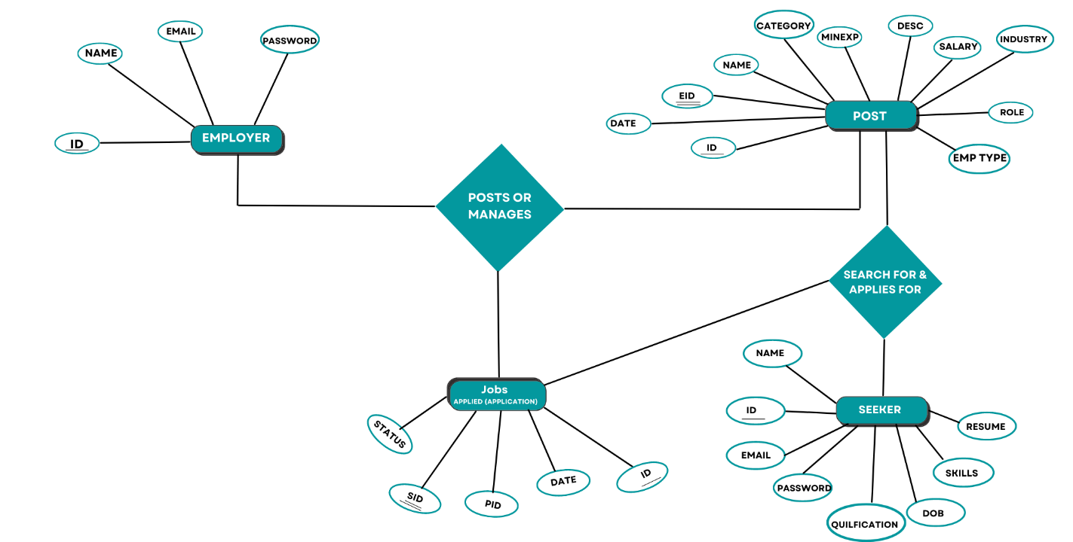

Fig(4.1)

The Entity Relationship model describes interrelated things of interest in specific domain of knowledge. In the fig (4.1), we have an employer who will post various jobs and manages all of them, and that post is also viewed by the seeker or seeker can search for specific job posts to apply. Employer can also manage seeker’s job applications.

CHAPTER 5

**PROBLEM FORMULATION**

**5.1 General Problem Definition**

Today, almost every action in the world is managed by a computer-based software program. As the life cycle became more complicated, various software systems, such as real-time business simulation, embedded, web-based, personal, and more recently artificial intelligence software, began to infiltrate every aspect of human contact. The manual method is in a nutshell, excruciatingly slow. We created this initiative for that reason. As a result, person can quickly search 1000+ jobs with and then can determine which is best for him without the assistance of others.

**5.2 Problem statement**

In the upgrading generation, manually finding jobs by using newspapers or asking others about vacancies is difficult. So online job portals will assist both companies and job seekers in finding the right place for them. From the comfort of their own homes. The job seeker can view all of the company's amenities and make the best decision possible. Employer can also find the best employees which they want.

**5.3 Aim of the project**

The aim of this application is to reduce the manual effort needed to find the best jobs and their details. A job portal provides an efficient search for online information on job vacancies for jobseekers. The main goal of this online job portal is to attempt to produce the right graduates get hired based on the industry needs.

**5.4 Main Objectives of the Project:**

* Single platform for viewing the job details.
* Enabling a user-friendly application.
* The purpose of the project is to reduce the manual work for managing the Interview, Jobseeker, Posts about Job etc.
* It helps to manage all the information about the employer & job seeker.
* It acts as a bridge between job seekers and companies.
* All the records of employee are seen by the employer in order to provide job for the Employee.

CHAPTER 6

**METHODOLOGY**

**6.1 General**

PHP and MySQL will be used to create this project. The user interface is made simple to use with graphics, allowing this application to be used by a wide spectrum of users. By registering, you will be able to see the numerous types of jobs that are available. The major goal of this program is to provide users with detailed job information.

Admin will be given access to the database where he can access all the information of employer, seeker etc. And can track all the information related to the job posts. He can also search for the jobs added by the job provider that are available. Job Seeker register himself by filling the required details on the job portal. After login he will search for the job on various conditions and he can apply for the jobs based on various conditions. He can see the response of the company and he can contact the company for interview. Job Provider register himself and his company and after login he will add new job posts and he can search for the job seekers on various condition and he can offer the job to job seeker according to the job profile and he can also see the response from the job seekers. The employers can view the job seekers who have applied through their posted job and they can accept or reject the application. The status of job application can be viewed by respective job seeker. So here we are concerned with the probability of job seekers entering the workforce, which is in turn calculated as the product of the probability of jobs being offered and the probability of jobs being accepted.

**6.2 Data Flow diagram**

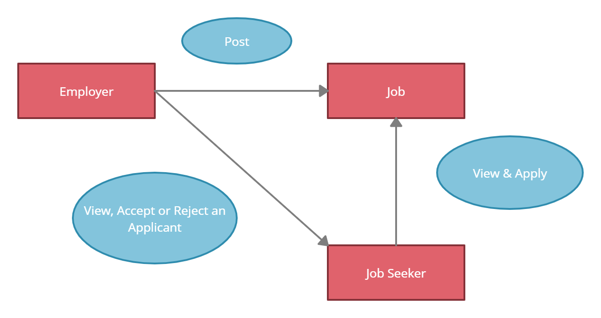

Fig 6.2(A) System Design

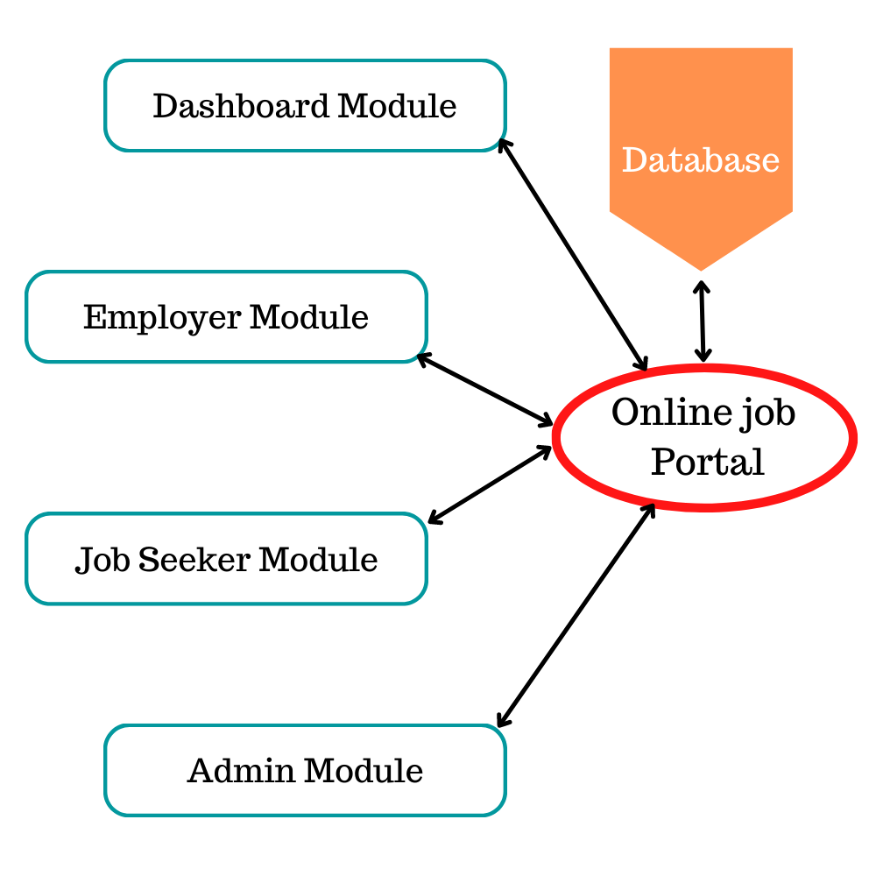

Fig 6.2 (B) Modules

**6.3 Database Table**

The database table figure is shown in fig 6.3(A)

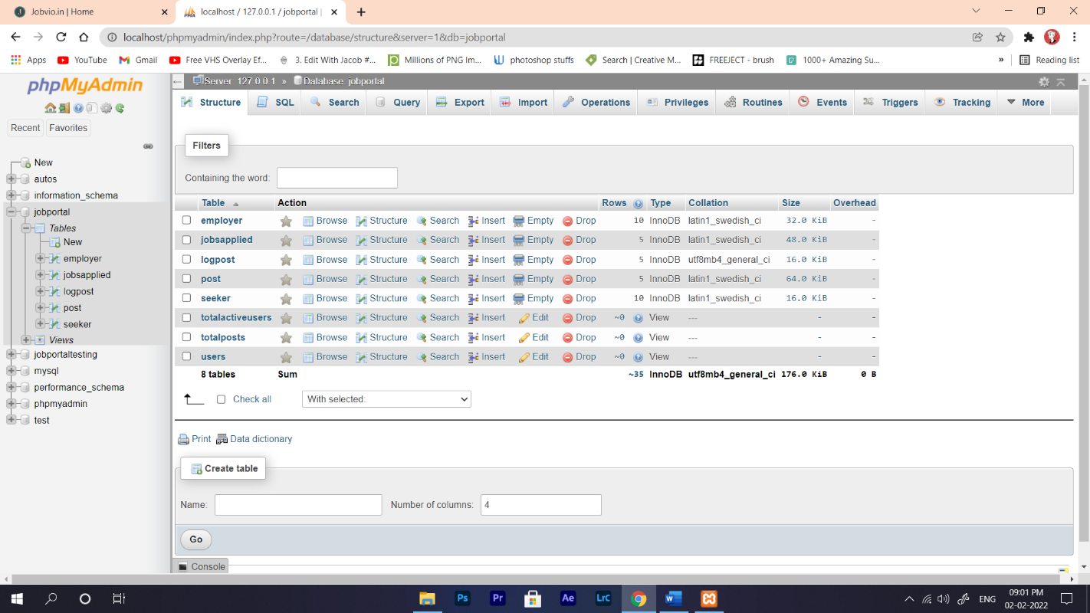

Fig 6.3 (A) Snapshot of Tables

The Fig 6.3(B) shows Employer table

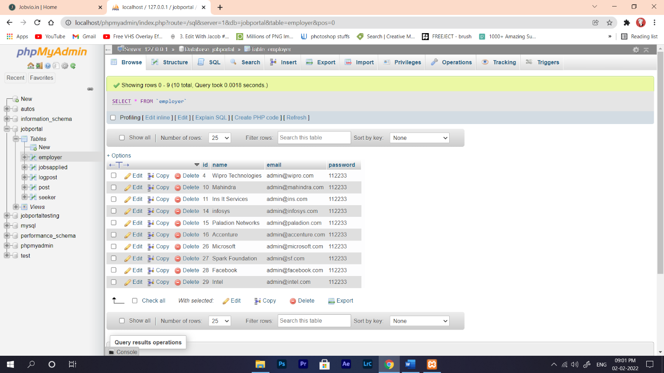

Fig 6.3 (B) Snapshot of Employer Table

The Fig 6.3(C) shows jobs applied table

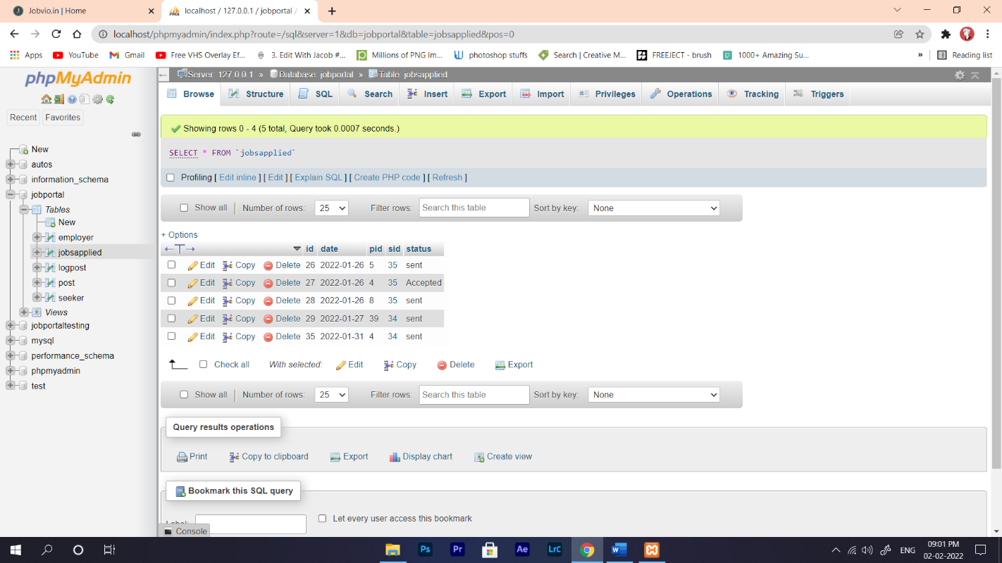

Fig 6.3 (C) Snapshot of Jobs Applied Table

The Fig 6.3(D) shows log post table

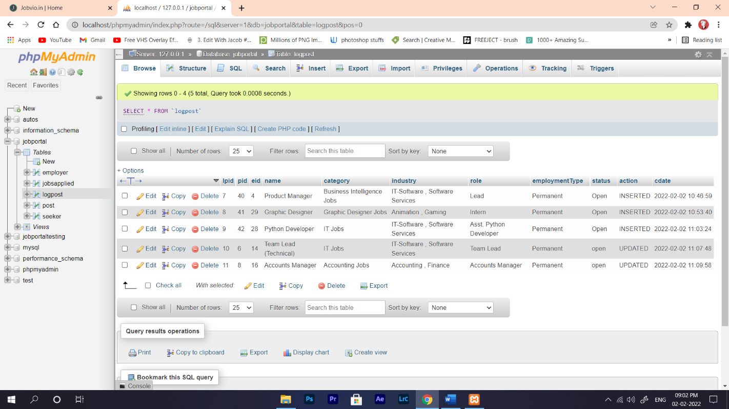

Fig 6.3 (D) Snapshot of Log Post Table

The Fig 6.3(E) shows post table

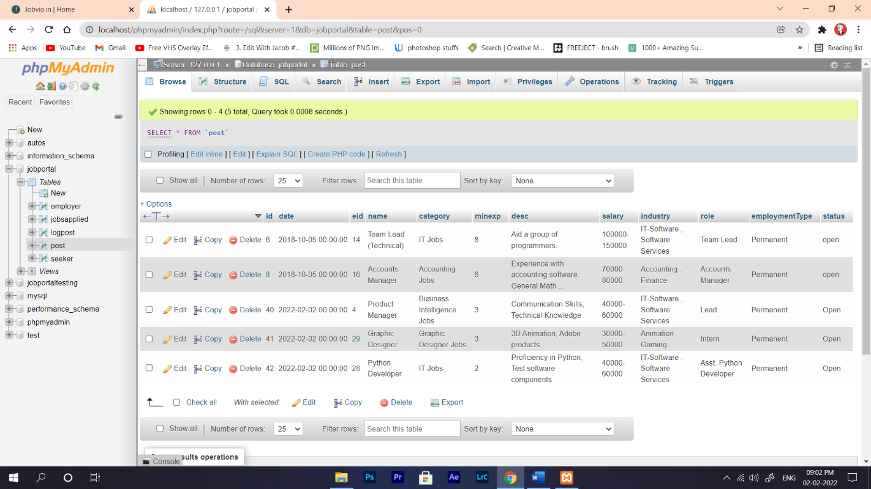

Fig 6.3 (E) Snapshot of Post Table

The Fig 6.3(F) shows seeker table

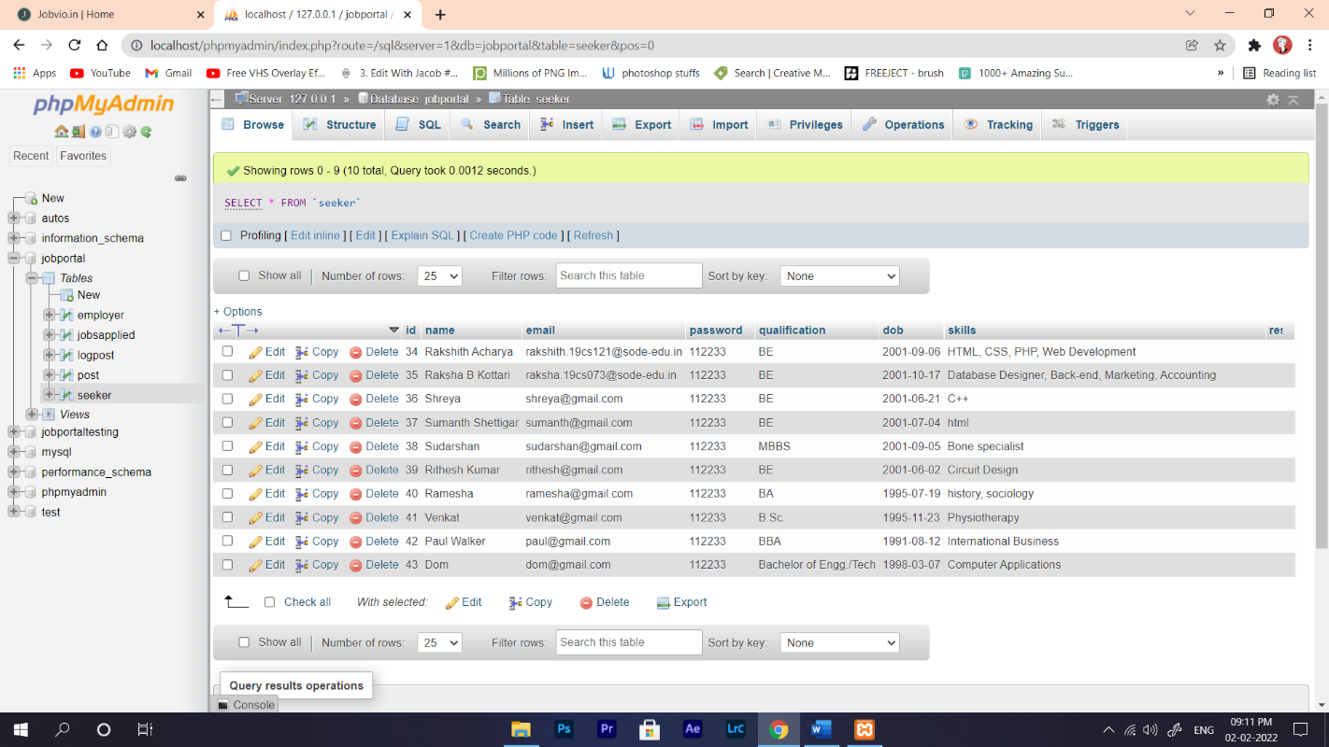

Fig 6.3 (F) Snapshot of Seeker Table

**6.4 Triggers**

A SQL trigger is a database object which fires when an event occurs in a database. We can execute a SQL query that will "do something" in a database when a change occurs on a database table such as a record is inserted or updated or deleted. For example, a trigger can be set on a record insert in a database table.

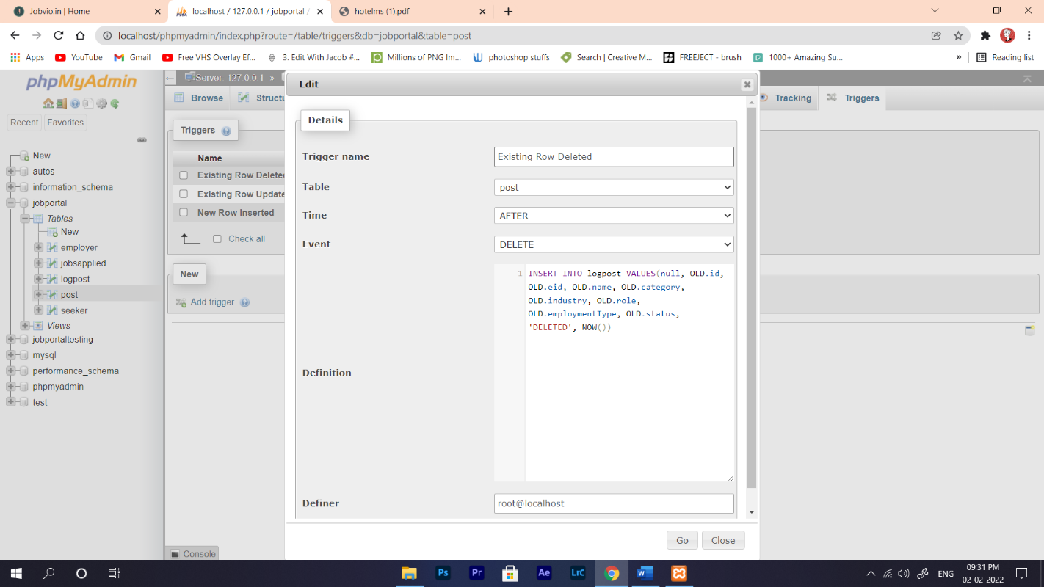 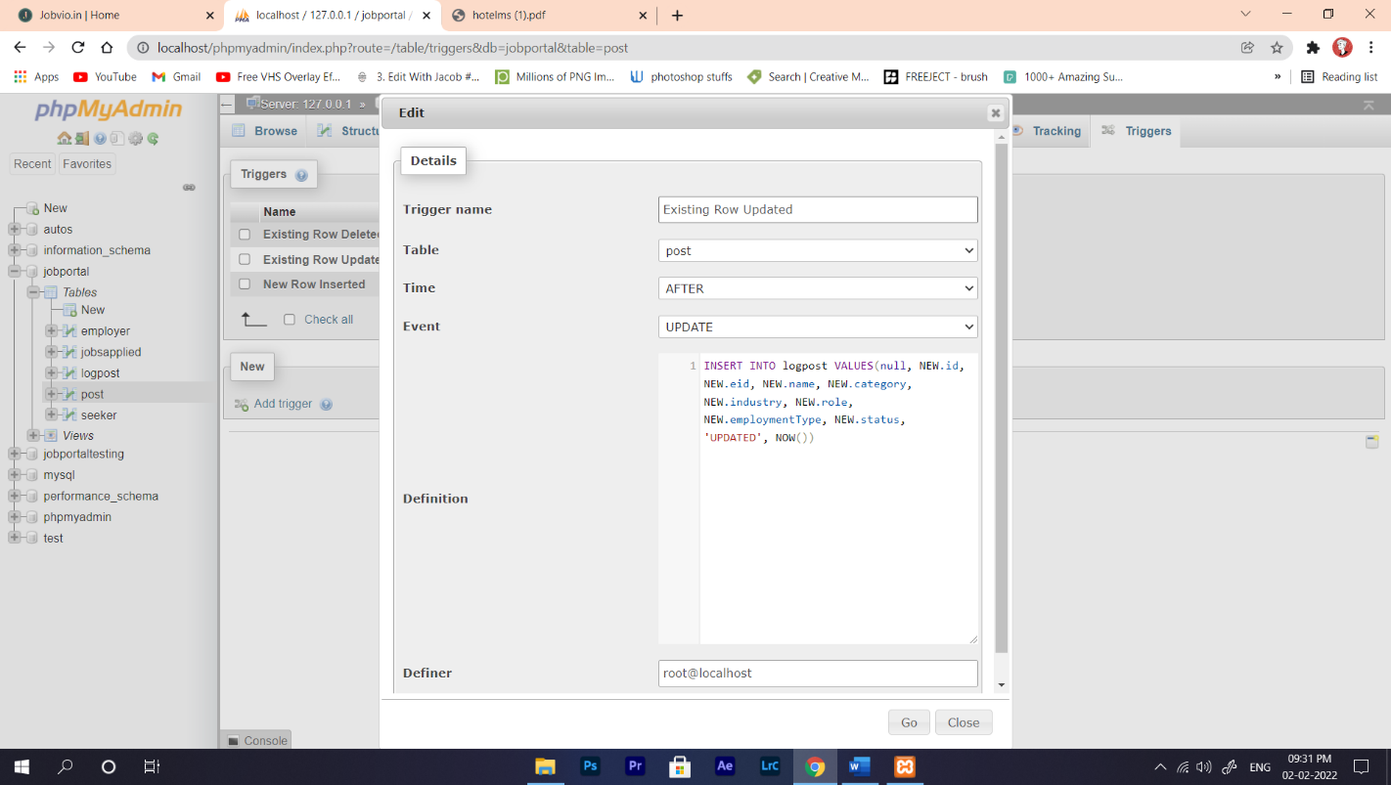

Fig 6.4 (A) Snapshot of Existing Row Deleted Fig 6.4 (B) Snapshot of Existing Row Updated

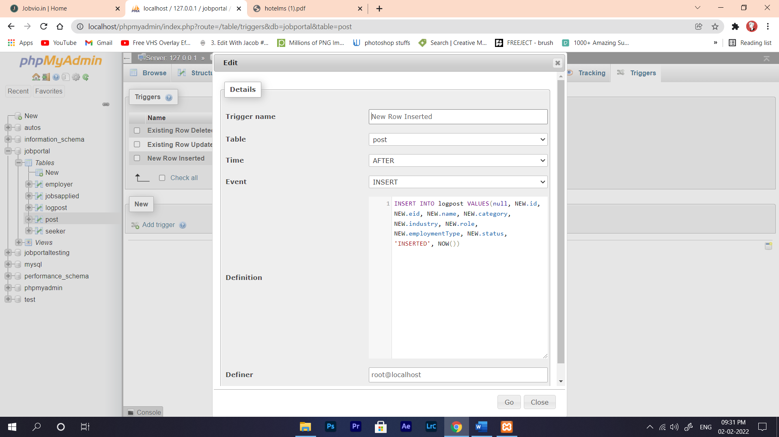

Fig 6.4 (C) Snapshot of New Row Inserted

The Fig 6.4(D) shows log post table



Fig 6.4 (D) Snapshot of Log Post Table

Here we have created 3 triggers named as New Row Inserted Fig 6.4 (C), Existing Row Updated Fig 6.4 (B), Existing Row Deleted Fig 6.4 (A). All these 3 triggers are applied on post table Fig 6.3 (E). Therefore, whenever an employer creates, updates or deletes a job post that data is inserted, updated or dropped from the post table Fig 6.3 (E) respectively. We have created logpost table Fig 6.4 (D) specifically to store the data of each and every post that are created by employer, even if they delete the job posts. These data are automatically triggered or inserted into the “logpost” table by all the 3 triggers.

**6.5 View Tables**

In SQL, a view is a virtual table based on the result set of an SQL statement. A view contains rows and columns, just like a real table. The fields in a view are fields from one or more real tables in the database. A view is created with the **CREATE VIEW** statement.

* **View Table "totalposts"**

*create view totalposts as*

*select count(id) as AllPosts from post;*

This view table is created to store the Total number of posts that are present in post table by using count.

The Total post table figure is shown in fig 6.5(A)

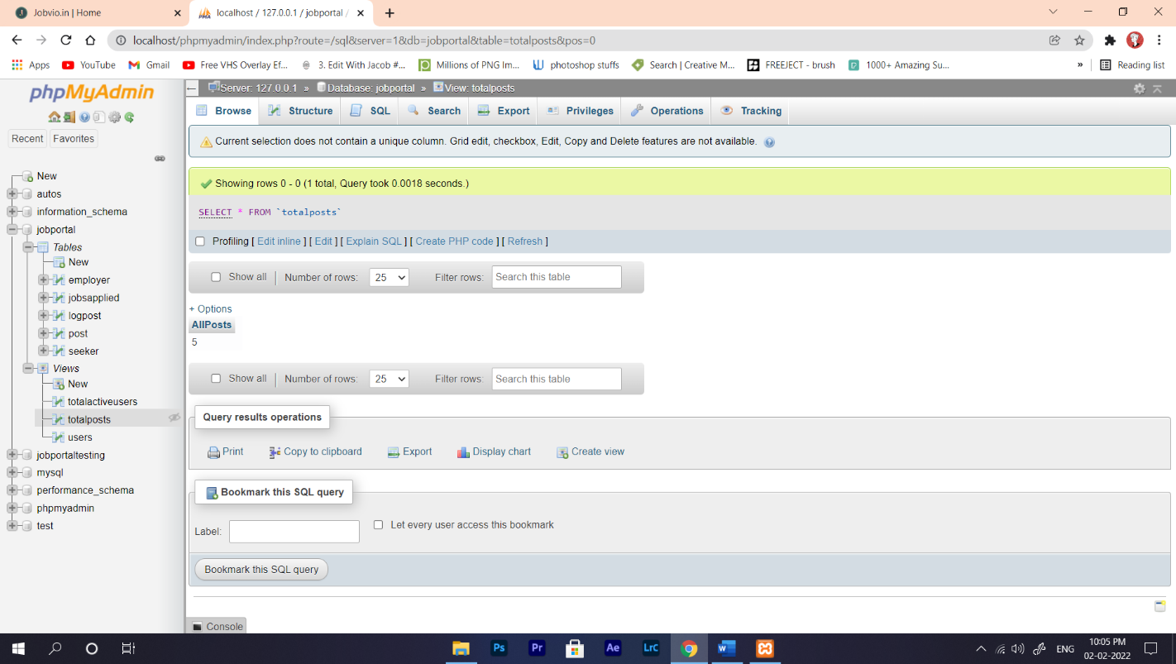

Fig 6.5 (A) Snapshot of Total post Table

* **View Table "users"**

**c***reate view users as*

*select count(id) as SeekersAndEmployers from seeker*

*union all*

*select count(id) from employer;*

This view table is created to store the number of seekers and number of employers that are present in both the “employer” and “seeker” table.

The User table figure is shown in fig 6.5(B)

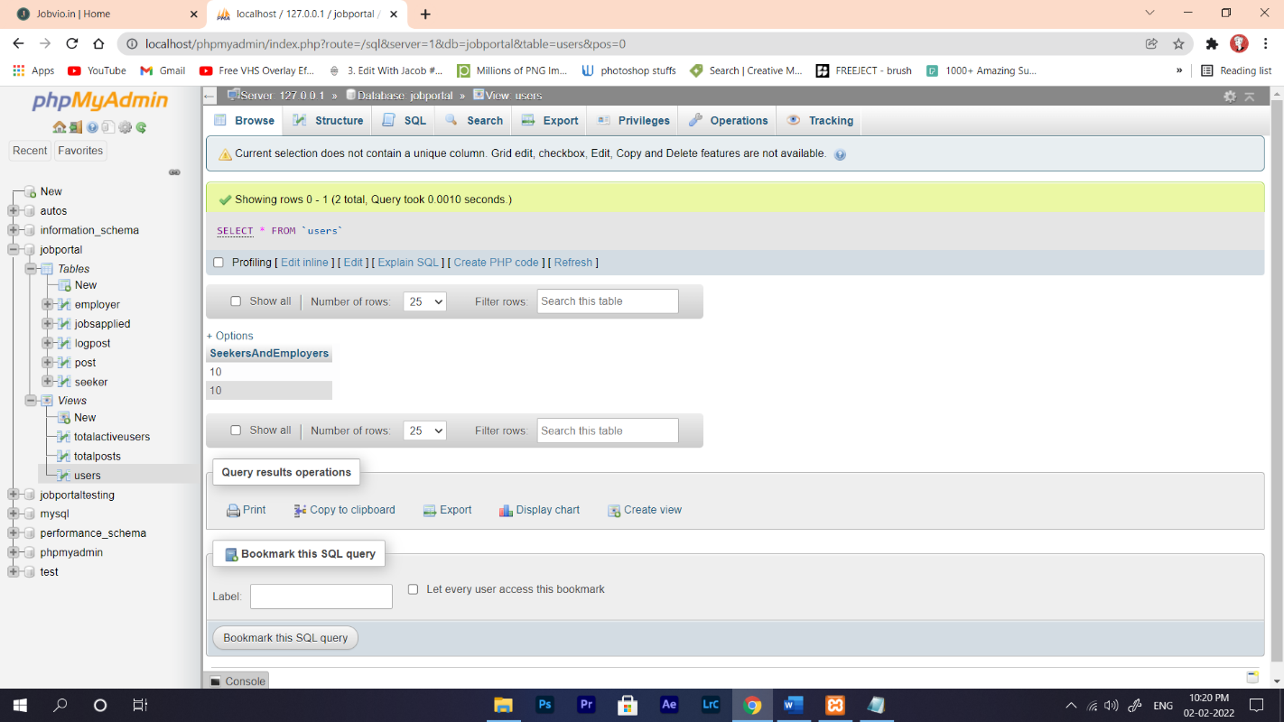

Fig 6.5 (B) Snapshot of User Table

* **View Table "totalactiveusers"**

*create view totalactiveusers as*

*select sum(SeekersAndEmployers) as TotalActiveUsers from users;*

This view table is created to store the number of all Active Users therefore, all registered employers and all registered seekers. This data is obtained by performing sum operation on previously created view table called “users”.

The Total Active User table figure is shown in fig 6.5(C)

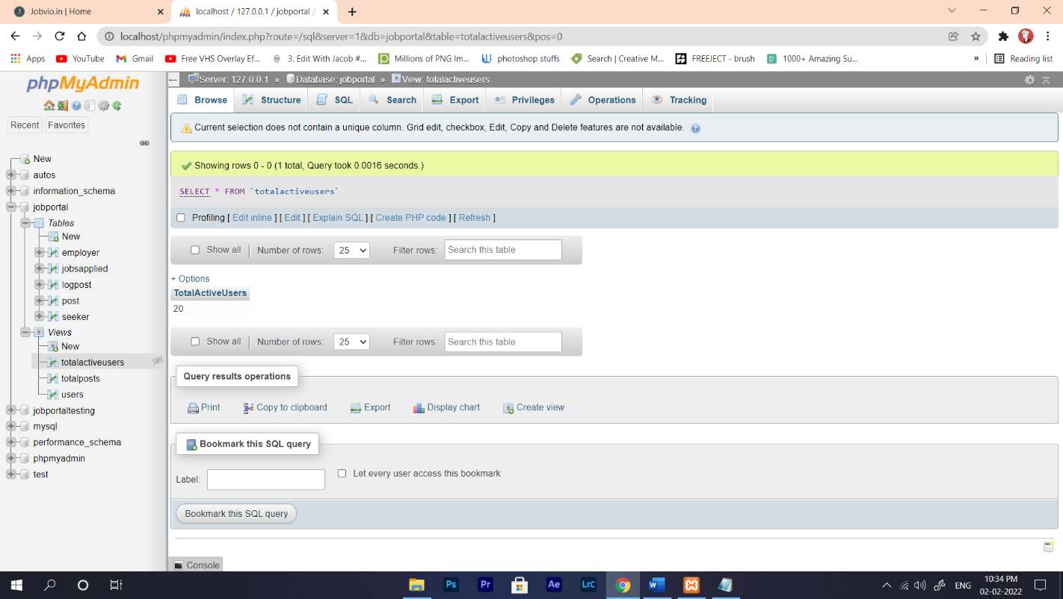

Fig 6.5 (C) Snapshot of Total active user Table

Among those three view tables i.e Fig 6.5(A)(B)(C), we have used two view table’s data (totalposts, totalactiveusers) to display in front end. Left out view table is used for ‘totalactiveusers’ view table to perform sum operation.

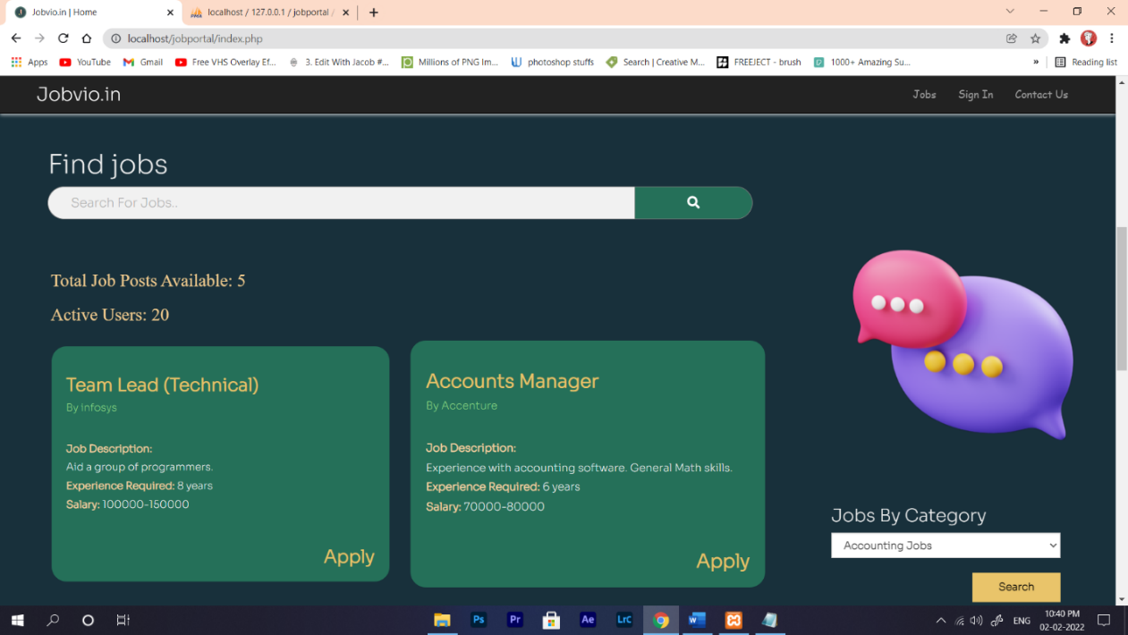

Fig 6.5 (D) Snapshot of view in the front end

CHAPTER 7

**Results And Discussions**

**7.1 Dashboard**

The Fig 7.1 (A) is the Home Page of Job Portal



Fig 7.1 (A) Snapshot of Home Page

The Fig 7.1 (B) is the Home Page of Job Portal

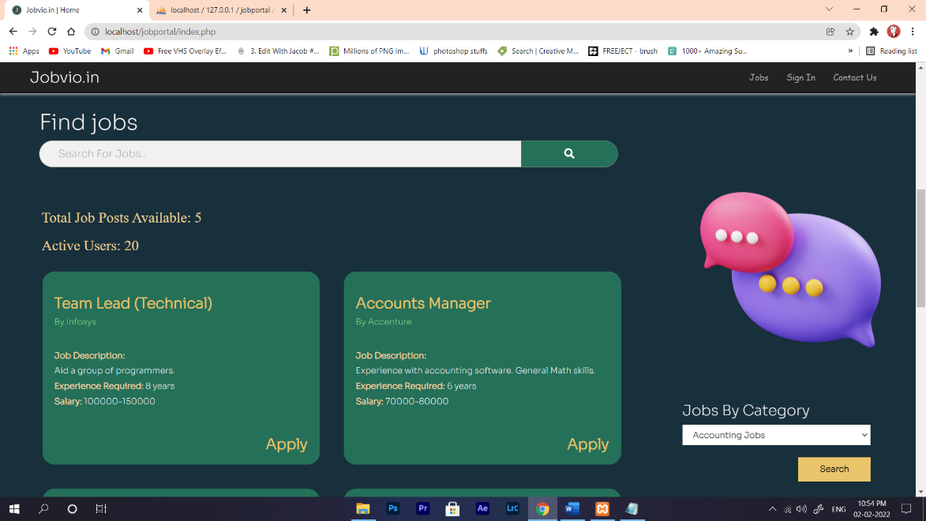

Fig 7.1 (B) Snapshot of Home Page

The Fig 7.1 (C) is the Home Page of Job Portal

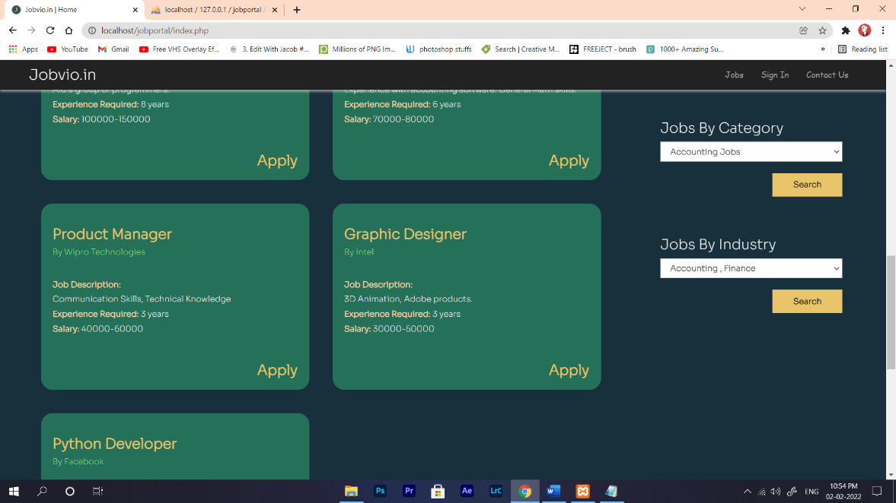

Fig 7.1 (C) Snapshot of Home Page

Front page of our system is dashboard where users even if they are not registered, they can still see the available job posts [Fig 7.1(B) and Fig 7.1(C)]. They can also search for the jobs using search bar as in Fig 7.1(A). There are also advanced search options for jobs by category and industry.

**7.2 Sign In & Sign Up Page**

The Fig 7.2 (A) is the Sign In Page of Job Portal

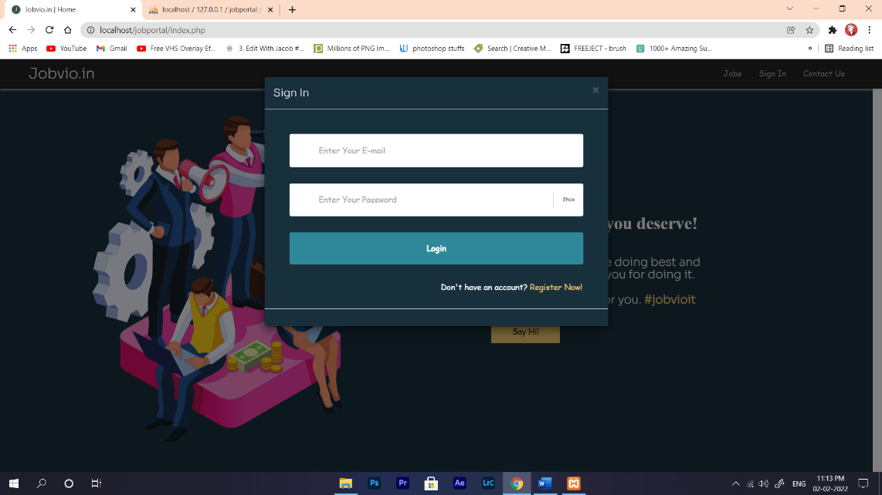

Fig 7.2 (A) Snapshot of Sign In

The Fig 7.2 (B) is the Registration page for Employer of Job Portal

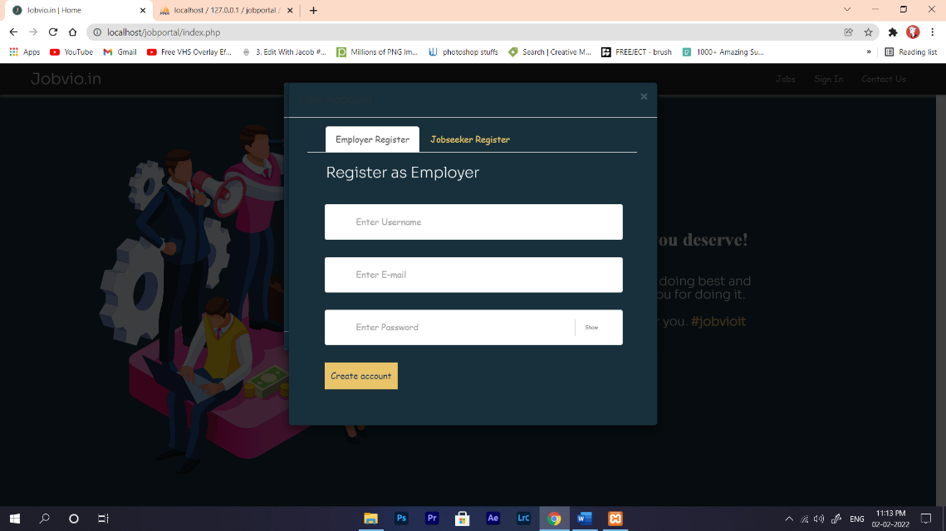

Fig 7.2 (B) Snapshot of Employer Register

The Fig 7.2 (C) is the Registration page for Employer of Job Portal

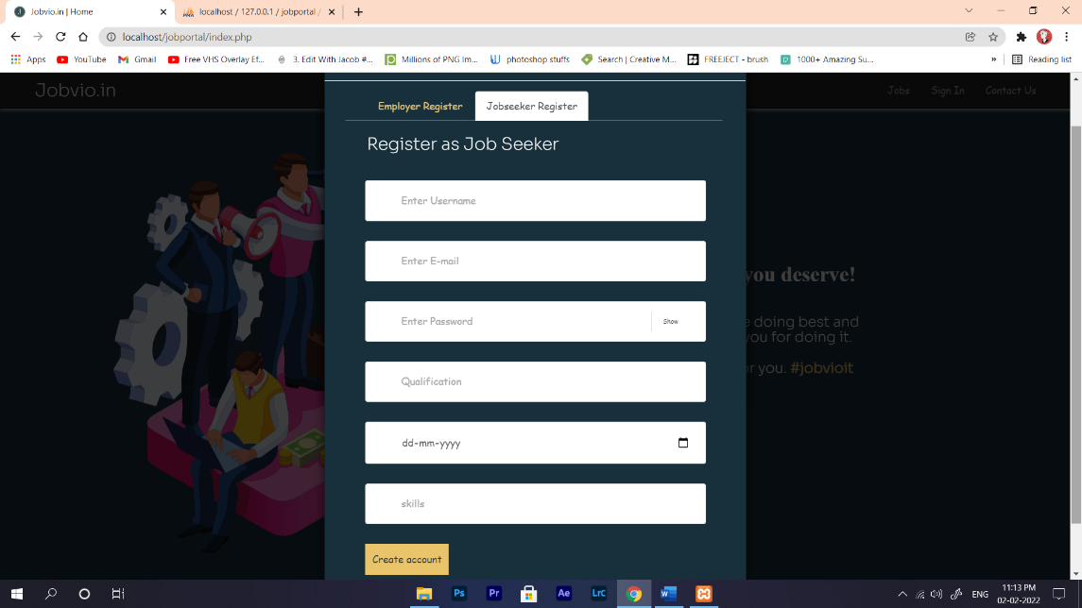

Fig 7.1 (C) Snapshot of jobseeker Register

Sign In page is used to login for all the employers and seekers for their respective accounts. If they don’t have an account then can register to have one. While registering they will get two options namely “Employer”, “Seeker”. Here user can register as an employer or seeker. They are supposed to enter the required details in order to create an account.

**7.3 Employer Account**

The Fig 7.3 (A) is the Employer’s Account in the Job Portal

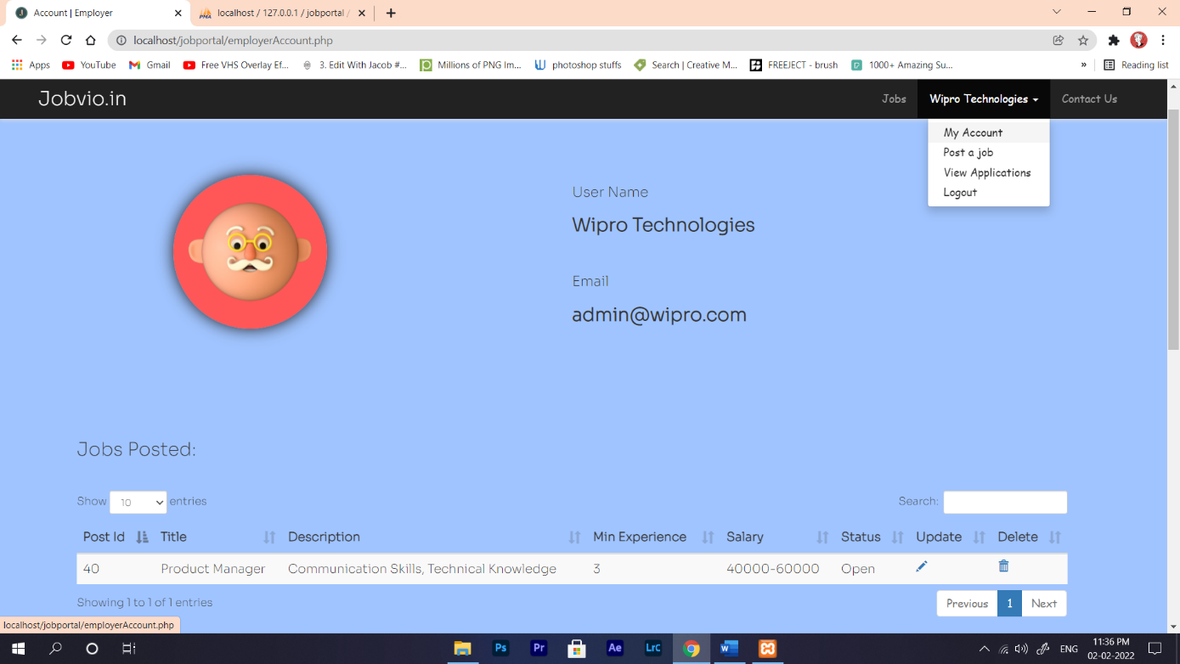

Fig 7.3 (A) Snapshot of Employer Account

The Fig 7.3 (B) is the page to post a job in the Job Portal

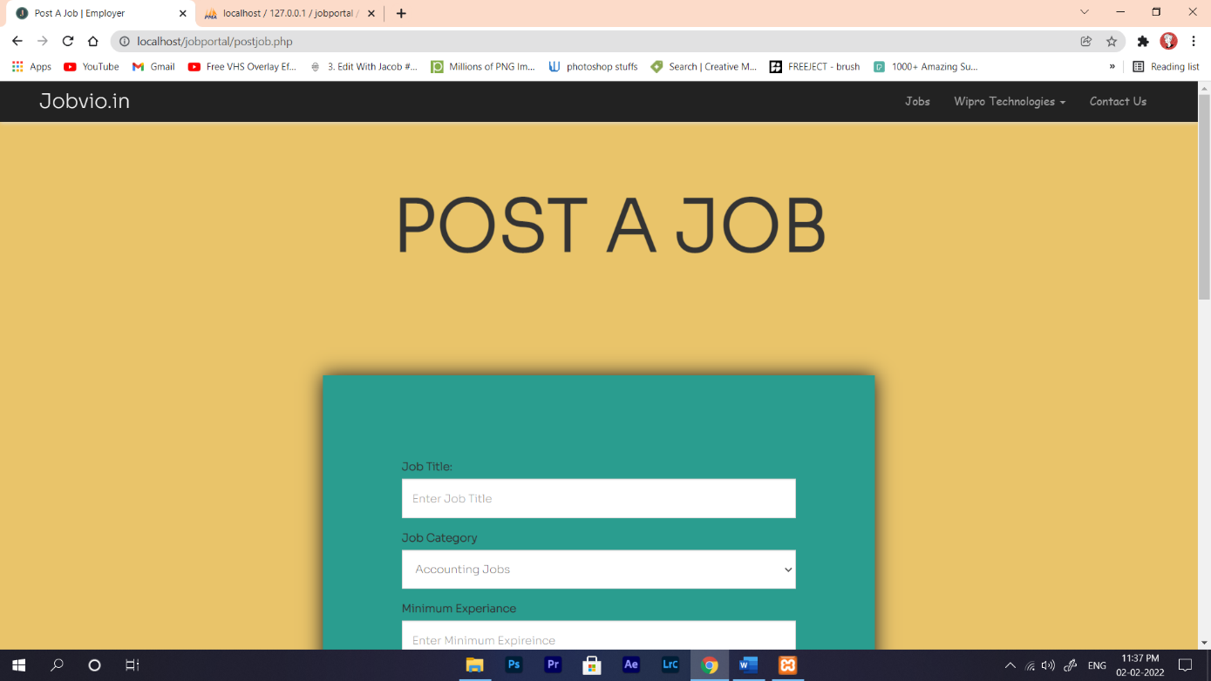

Fig 7.3(B) Snapshot of Job Post

The Fig 7.3 (C) shows the Application of job seekers in the Job Portal

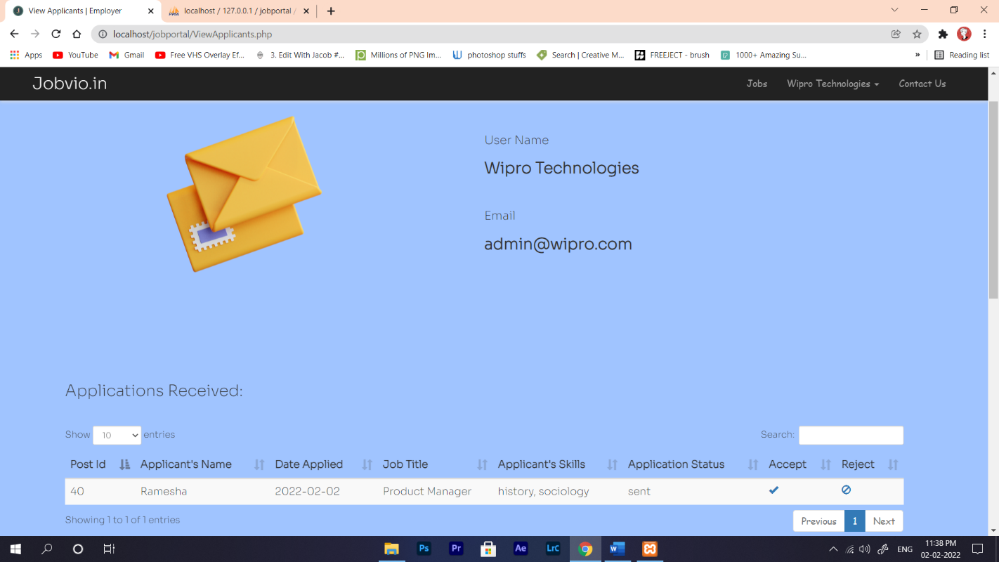

Fig 7.3 (C) Snapshot of Employer Account

In Fig 7.3 (C) We can see once the employer logs in to the account, he will have access to post a job post, to view the list of jobs posted by him and to view the list of applicants who have applied for the job posts. In “My Account” section employer can update or delete the job posts that are already published. In “Post a job” section employer can publish a new job post. And in “View Applications” section employer can see all the job seeker’s applications and can accept or reject it.

**7.4 Seeker Account Page**

Seeker’s my profile figure is shown in Fig 7.4 (A)

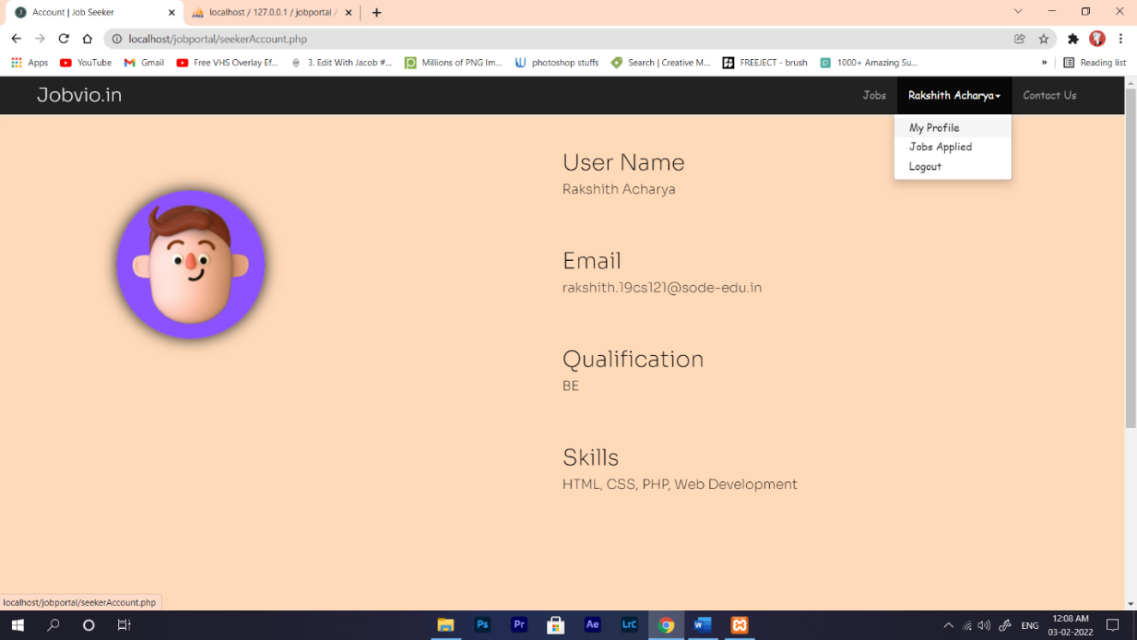

Fig 7.4 (A) Snapshot of Seeker Account

Jobs applied by the seeker is shown in Fig 7.4 (B)

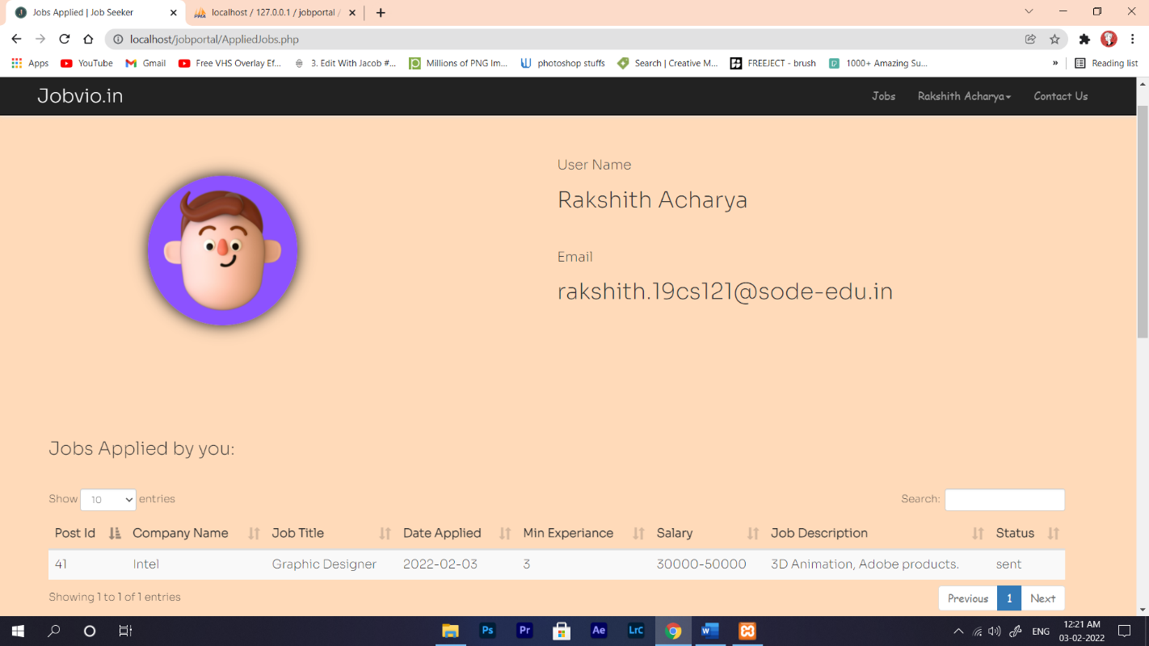

Fig 7.4 (B) Snapshot of Seeker Account

Job Seeker can login to his account through Sign In page and can have access to his account as shown in Fig 7.4 (B). He will get access to his profile in the job portal and also to view all the jobs for which he has applied. In “My Profile” section seeker can see the information about himself such as User Name, Email, Qualification, Skills which he has entered during registration of his account. In “Jobs Applied” section seeker can access all the jobs and related information that he has applied. He can also see the status of his application whether it is accepted or rejected.

**7.5 Footer**

Footer in Job Portal web Application

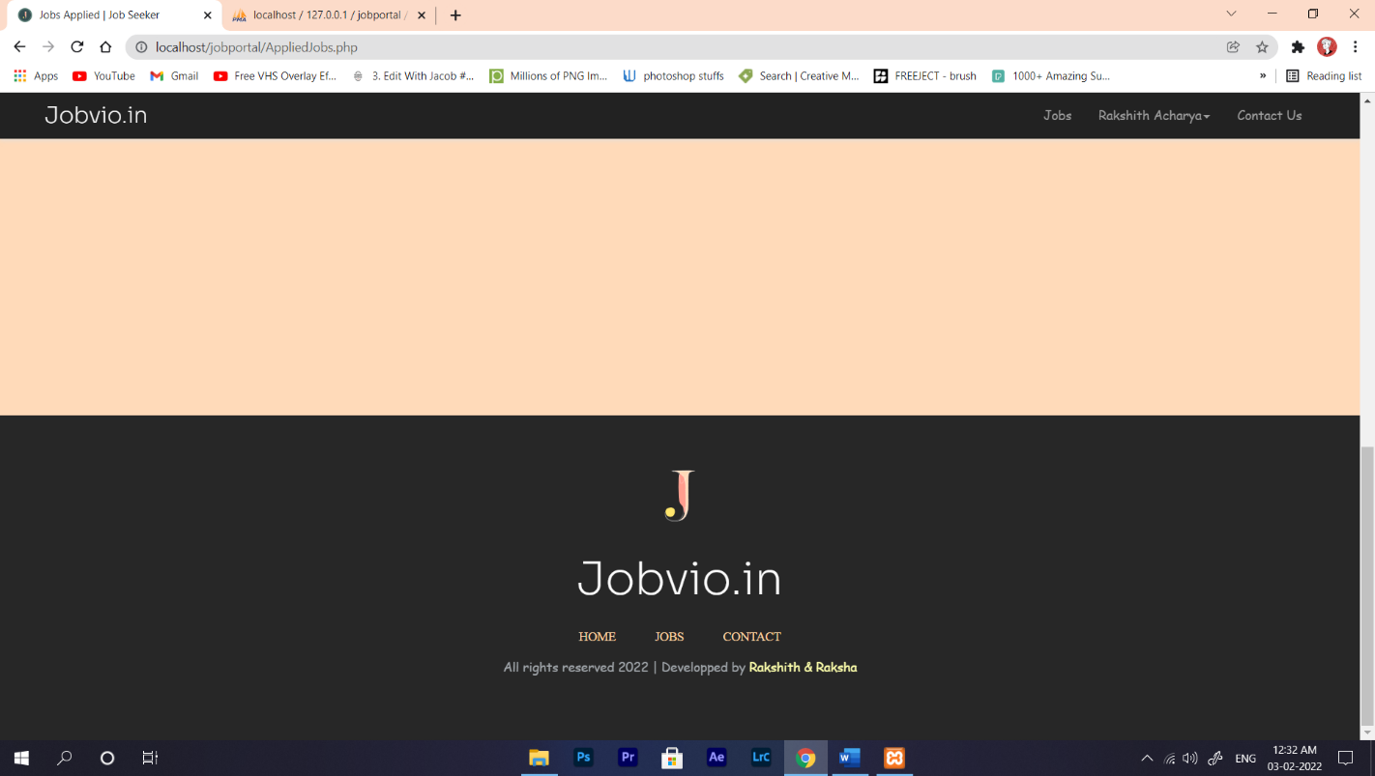

Fig 7.5 (A) Snapshot of Footer

As in Fig 7.5 (a) Footer contains “HOME”, “JOBS”, “CONTACT” options. Where “HOME” is linked to the home page of the system. “JOBS” is linked to the job posts where all the job posts are available. “CONTACT” is linked to the admins email address.

CHAPTER 8

**Conclusion**

**8.1 General**

Analyses of different methods of job search used and their efficacy should provide information that can be used for developing better ways of helping unemployed job seekers find employment. Moreover, knowledge about the factors surrounding typically unsuccessful job search could help individuals and labor market intermediaries to channel their resources more effectively. While the Internet has become seemingly ubiquitous in job search for the highly qualified and for those in professional and associate professional occupations, it has also made important inroads in other segments of the labor market. It is used by a majority of job seekers from all occupational groups. A job web portal provides an efficient search for online information on job vacancies for jobseekers. The main goal of this portal is to attempt to produce the right graduates based on the industry needs. However, it is important that be aware the job web portals can never fulfill all the problems of jobless graduates.

**8.2 Scope of Future Work**

* Computer applications can be developed to reach out more users.
* Mobile number could be added to user for authentication purpose and security purpose.
* Notifications can be sent to phones whose records are near to expiry.
* Online job selection process can be implemented therefore aptitude, technical testing etc.

**References**

1. J. Dorn and T. Naz, “Integration of Job portals by Meta-search,” in Proc. 3rd International Conf. on Interoperability for Enterprise Software and Applications, Funchal, Portugal, 2007, pp. 401-412.
2. M. Mansourvar and N. Y. Mohd, “Web portal as a knowledge management system in the universities,” World Academy of Science, Engineering and Technology, vol. 70, pp. 968-974, 2010.
3. M. Gangle, “The only way is up? Employment protection and job mobility among recent entrants to European labour markets,” European Sociological Review, vol. 19, pp. 429, 2007
4. M. Mansourvar, Development of a Job Web Portal to Capture Industry’s Needs, 2011.
   1. Weber and H. Mahringer, “Choice and success of job search methods,” Empirical Economics, vol. 35, no. 1, pp. 153-178, 2008.